Patient identifies the problem. He she can use clickable image. The doctor can also use it while questioning the patient

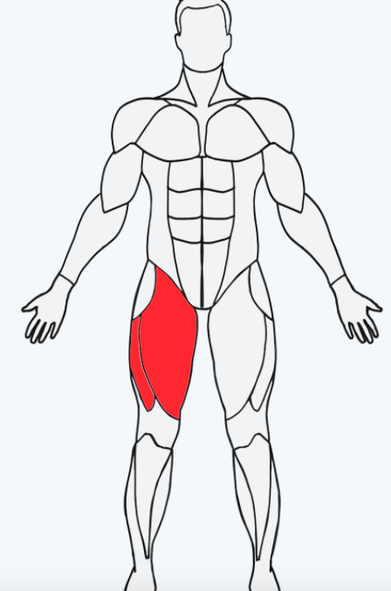

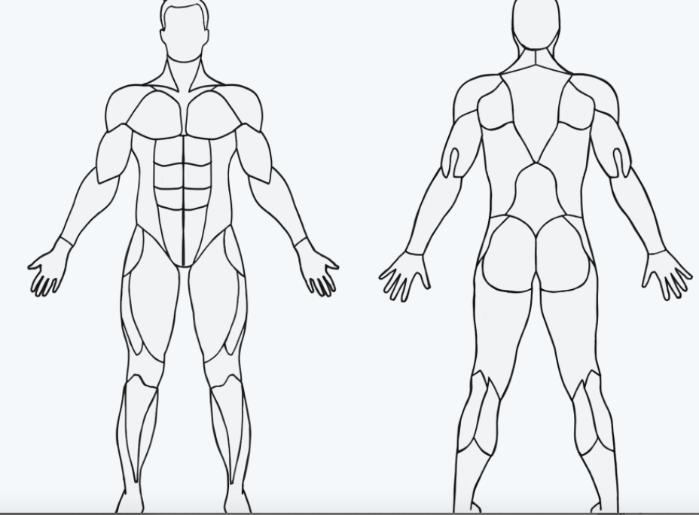

2. Patient responds to a list of questions. It can be through in

3. Physio does the assessment & creates a plan



